**SRI SIDDHARTHA ACADEMY OF HIGHER EDUCATION**

**SRI SIDDHARTHA DENTAL COLLEGE AND HOSPITAL**

**SEXUAL HARASSMENT ELIMINATION COMMITTEE**

**Report on Gender sensitization programme-2018**

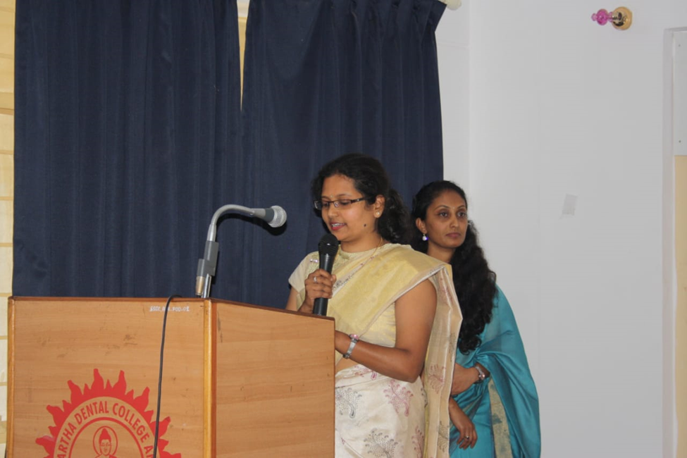

**Gender sensitization program** has been organized by the Sexual Harassment Elimination Committee on **11th December 2018, 10:15 AM at AV hall**, **Sri Siddhartha Dental College** under the theme **“GETTING THE BALANCE RIGHT”**

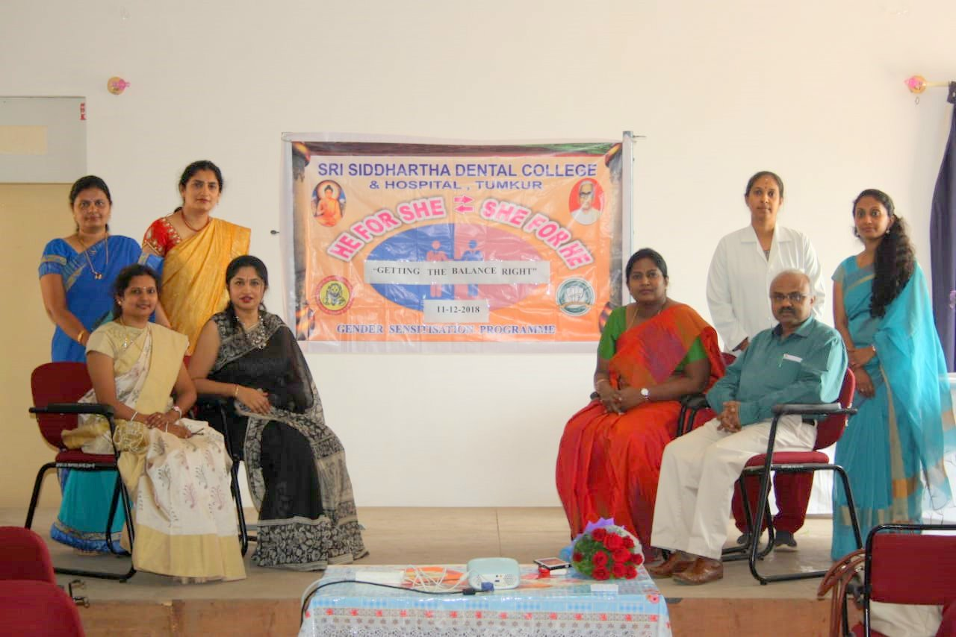

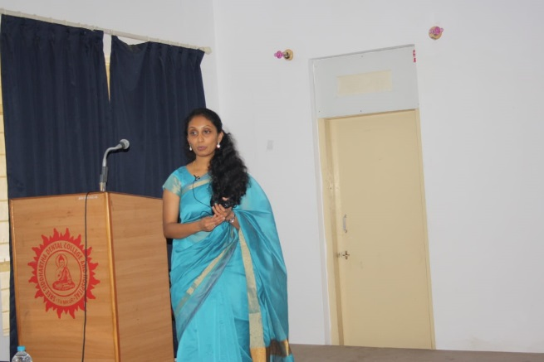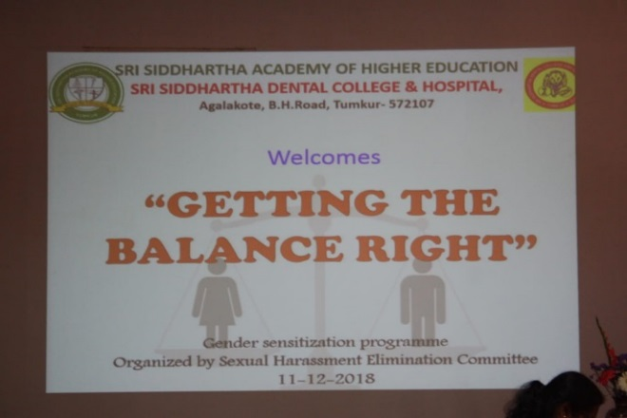

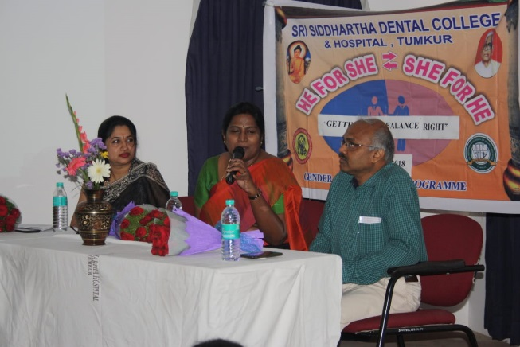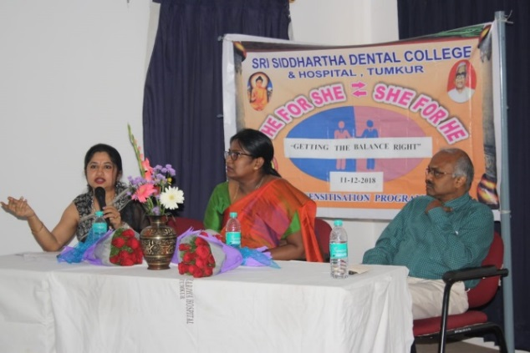

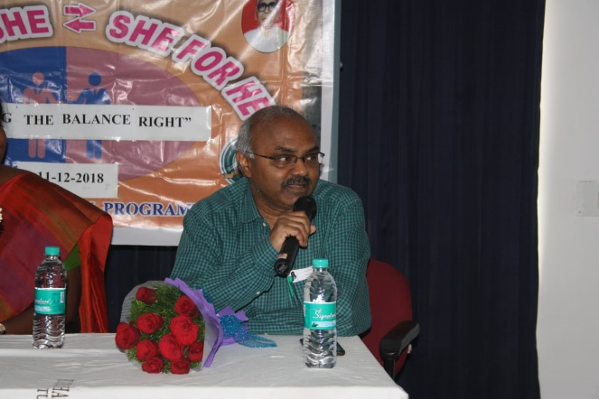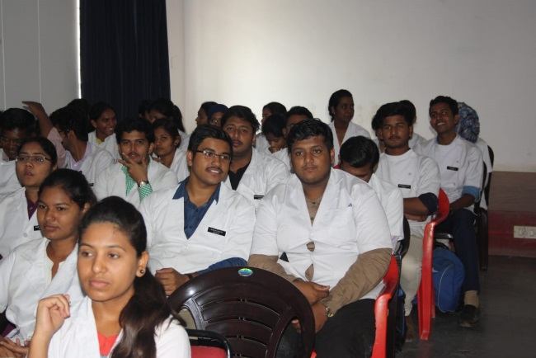

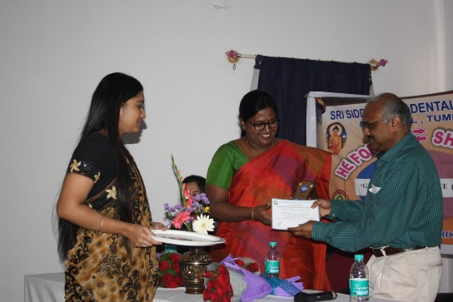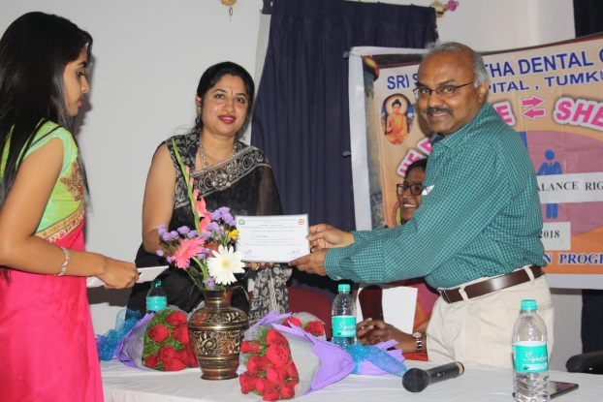

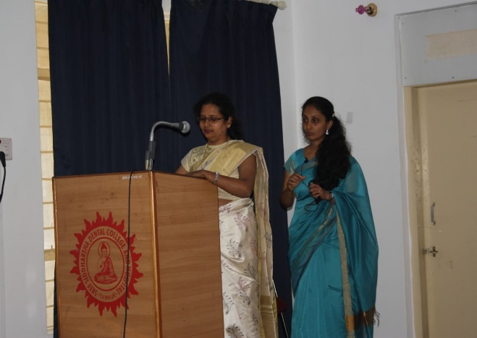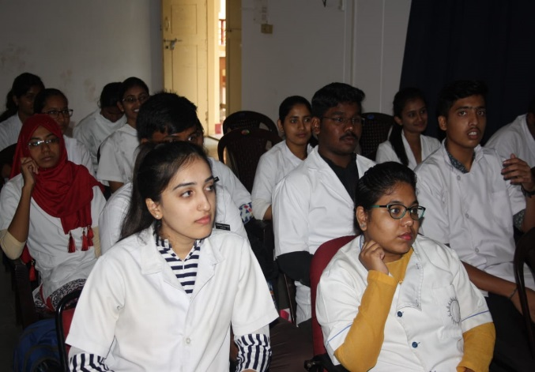

**Chairperson Co-ordinator of Human Resources Chairperson IQAC/ Sexual Harassment**  **Dr Sanjay Venugopal Principal**   **Elimination Committee Dr K R Kashinath Dr Laxmidevi B L**